
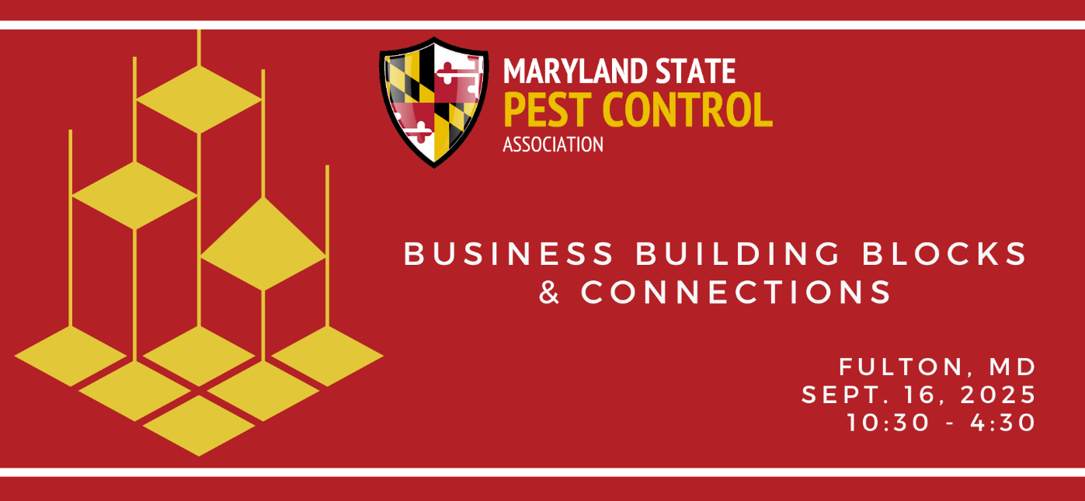
Cody Barbour, CRO and Co-Founder, Baton
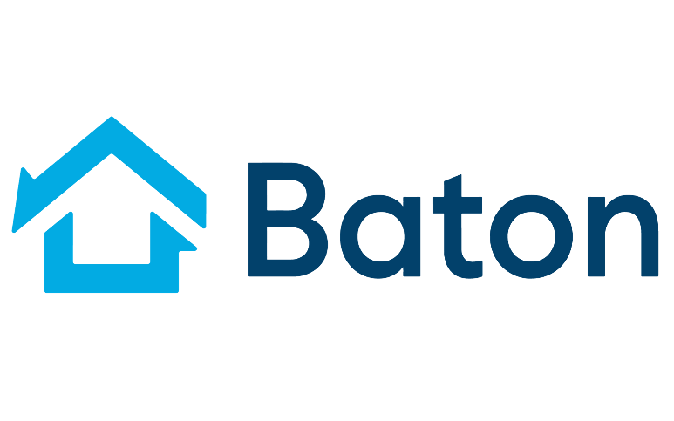
Growing up in California as the son of an entrepreneur, Cody is one of the co-founders of Baton. In the pest control industry since 2021, Cody has become passionate about the people of the pest control industry. Cody loves being outdoors and also enjoys playing and watching sports. Being a West Coast kid, his allegiances align with the Kings, Raiders, and Giants.

