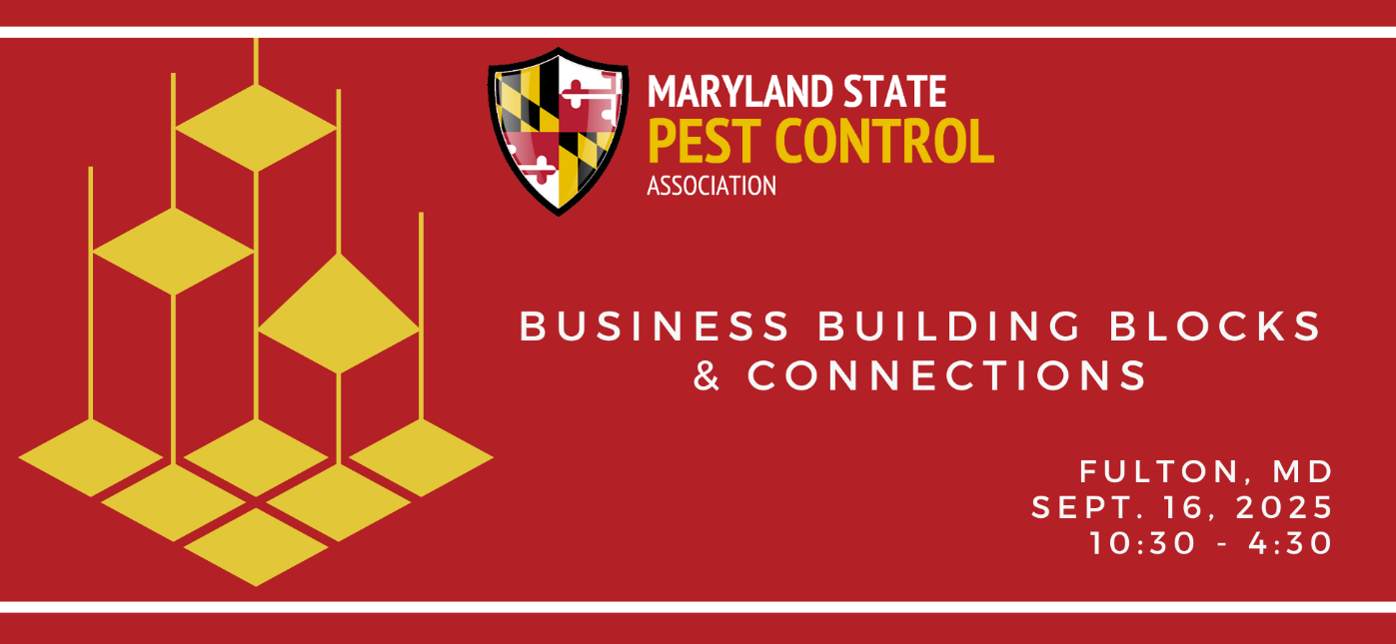
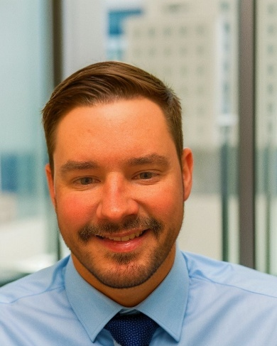
Tyler Anderberg, Enterprise Fleet Management
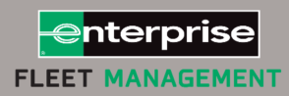
Tyler Anderberg is a seasoned business development professional with over 10 years of experience at Enterprise Fleet Management. He currently oversees a diverse territory that includes Central Maryland, the Eastern Shore, and Northern Maryland, where he specializes in onboarding new business partnerships. Tyler has worked with a wide range of clients from government agencies to commercial operations, helping organizations with fleets of all sizes optimize performance, reduce costs, and streamline operations. His role involves developing tailored fleet strategies and building long-term relationships that drive measurable impact.

